Web Scraping Report

## Introduction

This project focuses on scraping data from *eodata*  which is a website that provides historical market data. It has an extensive collection of historical data across different exchanges. For this project, we are mainly going to focus on the Toronto Stock Exchange (TSX).

From TSX page, data regarding the highest value, lowest value, closing value, and stock volume were gathered for the first few companies with the company name/code starting with ‘A’.

To facilitate web scraping, Python libraries such as requests and BeautifulSoup were employed.

## Data Characteristics

The collected data are web resources written in html format. Python’s default html parser were used to analyze or organize the text into logical syntactic format.

## Data Processing

No data processing involved.

## Data Output

The scraped data was formatted into a DataFrame using the Panda’s Library and was then saved externally as a csv file.

## 

## 

## Project Findings

The Toronto Stock Exchange has a total of 115 companies with company name/code starting with the letter A. Of these 115 companies, Ag Growth International Inc 5 Pct Debs closed with the highest value at 126.3. The other companies with the 10 highest closing values are shown in the graph below.

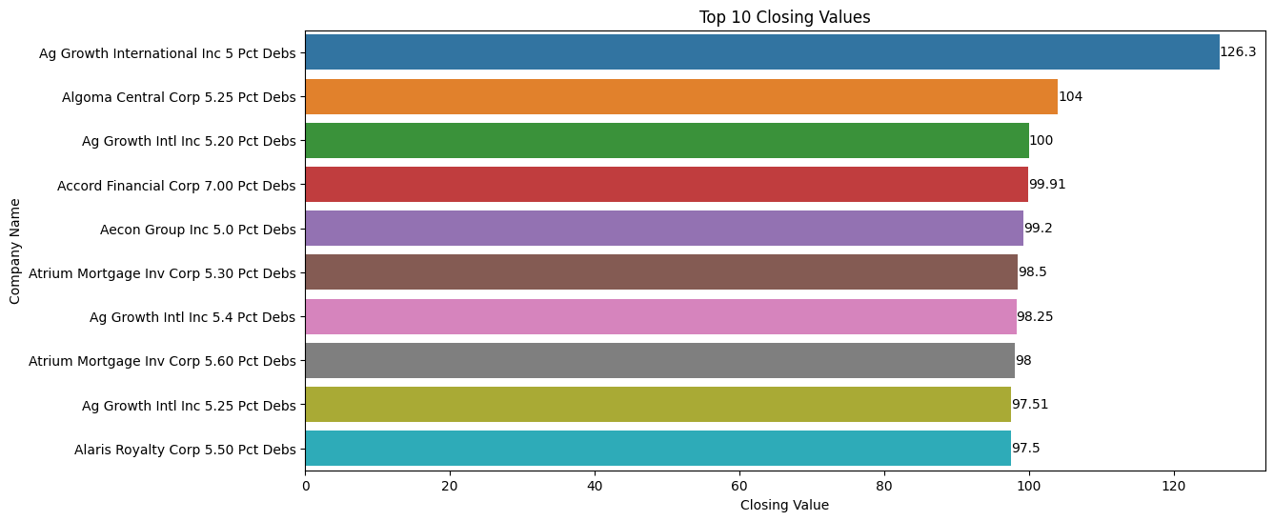

The company with the greatest change in its stock value is Atrium Mortgage Inv Corp 5.10 Pct Debs with its stock increasing by 6.17%. Aleafia Health Inc 8.50 Debs Ser A places second on this list but with a decrease in its stock value of 2% instead. The other companies with significant changes in stock value are shown in the graph below.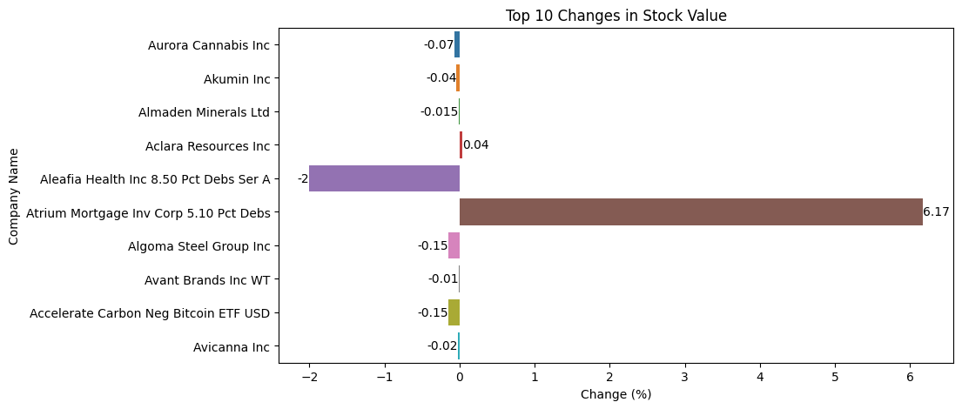

The companies with company name/code starting with letter A with the highest volume of stock in the Toronto Stock Exchange is Algonquin Power and Utilities Corp with a volume of 4.58x10^6. The top 10 companies in terms of volume of stock is summarized in the graph below